**Pharmeasy.in (online pharmacy and medical store in India)**

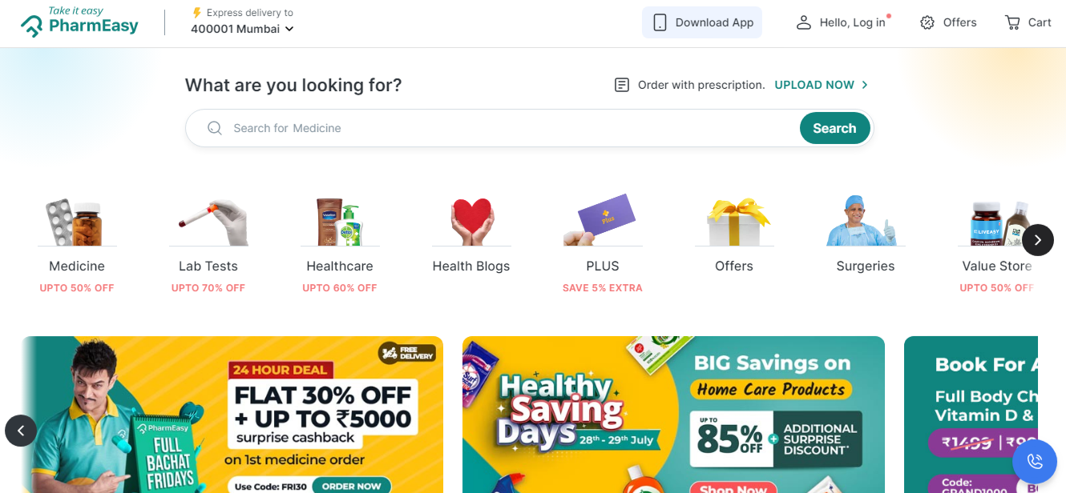

**About Pharmeasy**

**Type – private**

**Industry – Healthcare E-commerce Information technology retail**

**Founded – 2015 ,7 years ago**

**Headquarters – Mumbai , Maharastra ,India Area served – India**

**Products – Medicine supply Healthcare Products Website -** [**www.pharmeasy.in**](http://www.pharmeasy.in)

**Logo**



**Documentation Details**

1. **Header –**
   * 1. **Navigation bar**
        + 1. **Logo**
          2. **Address search**
          3. **Medicine searchbar**
          4. **Login**
          5. **Offers**
          6. **carts**
     2. **Upload prescription**
     3. **Search bar for medicine search**
2. **Offer Section –**
   * 1. **Medicine ,lab test ,health care , offers**
3. **Banner Section –**
   1. **4 image with slider**
4. **Special offer section –**
   1. **First user login**
5. **Category section –**
   * 1. **Covid essentials**
     2. **Personal care**
     3. **Drinks**
     4. **Beauty**
     5. **Skin care**
     6. **Home care**
     7. **Ayurvedic care**
     8. **Sexual wellness**
     9. **More**
6. **Upload prescription section –**
   * 1. **Upload**
     2. **How does this work**
7. **New launches section –**
8. **Trending near you section –**
9. **Lab test section –**
10. **Plus member add –**
11. **Shop by concern section –**
    * 1. **Skin care**
      2. **Vitamin supplements**
      3. **Diabetic care**
      4. **Baby and mom care**
      5. **Covid care**
      6. **Lifestyle disorder**
12. **Book lab test section –**
    * 1. **Advance full body checkup**
      2. **Covid-19 ITPCR**
      3. **Post prandial blood checkup**
13. **Payment offers section –**
    * 1. **Amazonpay**
      2. **Paytm**
      3. **Mobiquick**
      4. **Olamoney**
      5. **Freecharge**
      6. **Airtel payments bank**
14. **Wellness Essential of the week section –**
15. **Feature brand section –**
    * 1. **Glucon-d**
      2. **Sugerfree**
      3. **Evion**
      4. **Liveasy**
      5. **Huggis**
      6. **Wellbeing nutrition**
      7. **Revital**
      8. **volini**
      9. **More…….**
16. **Deals of the day section –**
17. **In the spotlight section –**
18. **Health articles section –**
19. **Why choose us section –**
20. **Customer review section –**
21. **Pharmeasy app add section –**
22. **Footer section –**
    * 1. **Company**
      2. **Fetured categories**
      3. **Need help**
      4. **Our services**
      5. **Policy info**
      6. **Our payments partner**